1. List all students with a total credit count of 0.

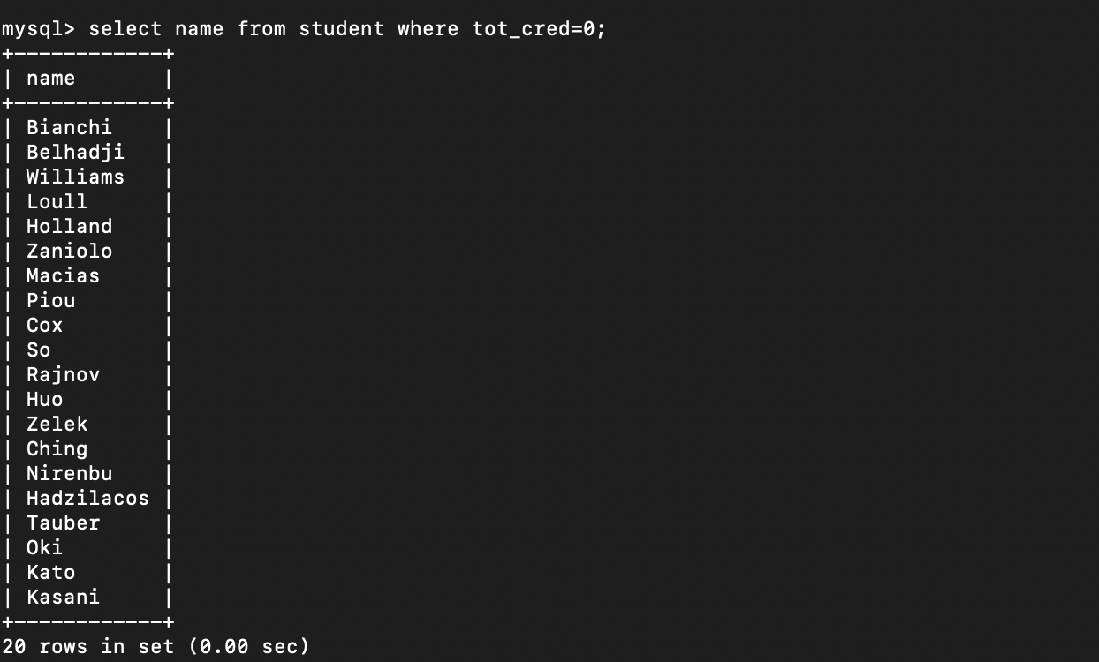

2. Find the names of all courses offered by the "Physics" department.

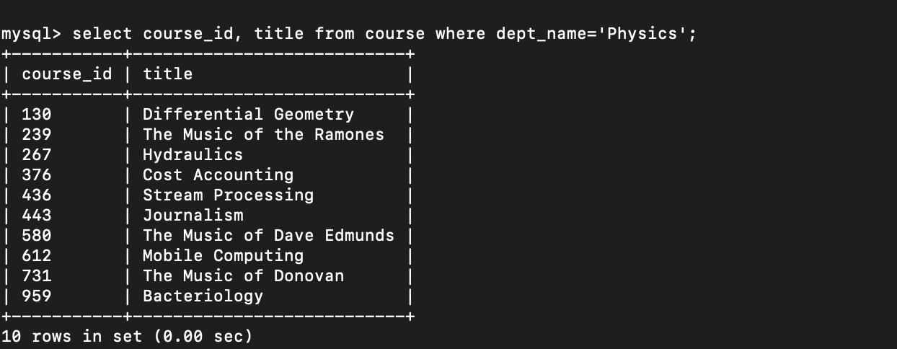

3. Retrieve the names of all instructors who earn Greater than equal to ₹50,000.

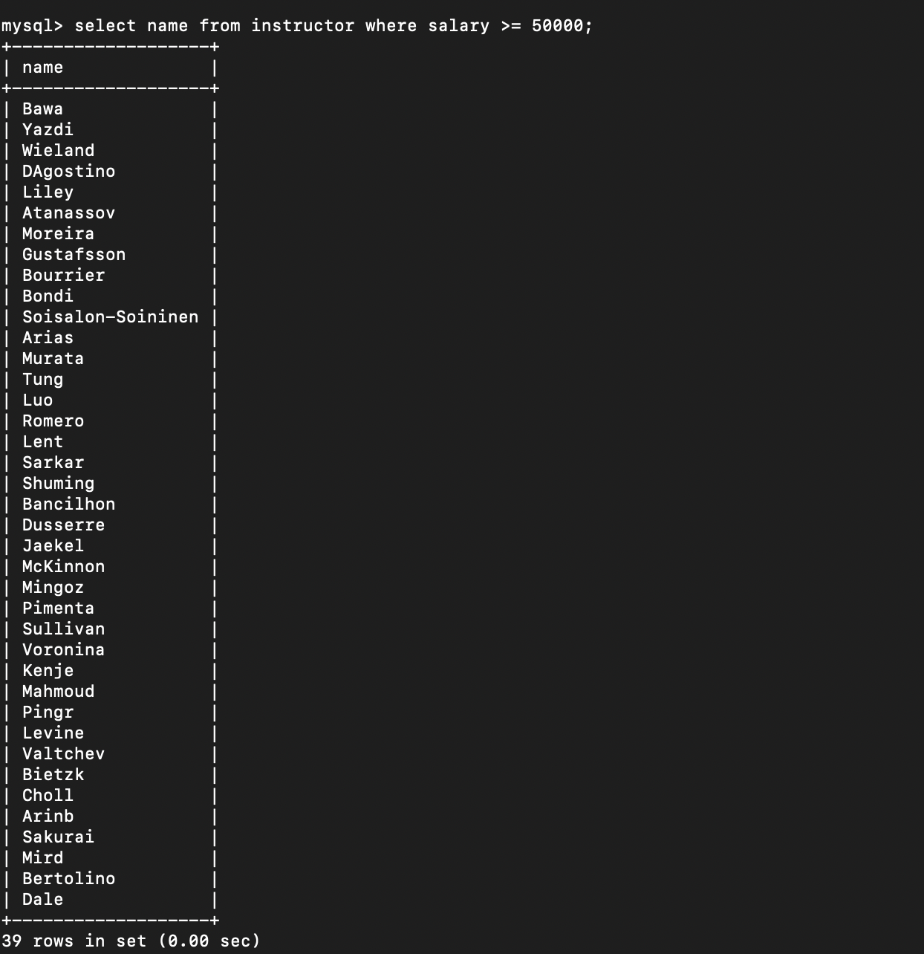

4. List all classrooms with a capacity of exactly 100.

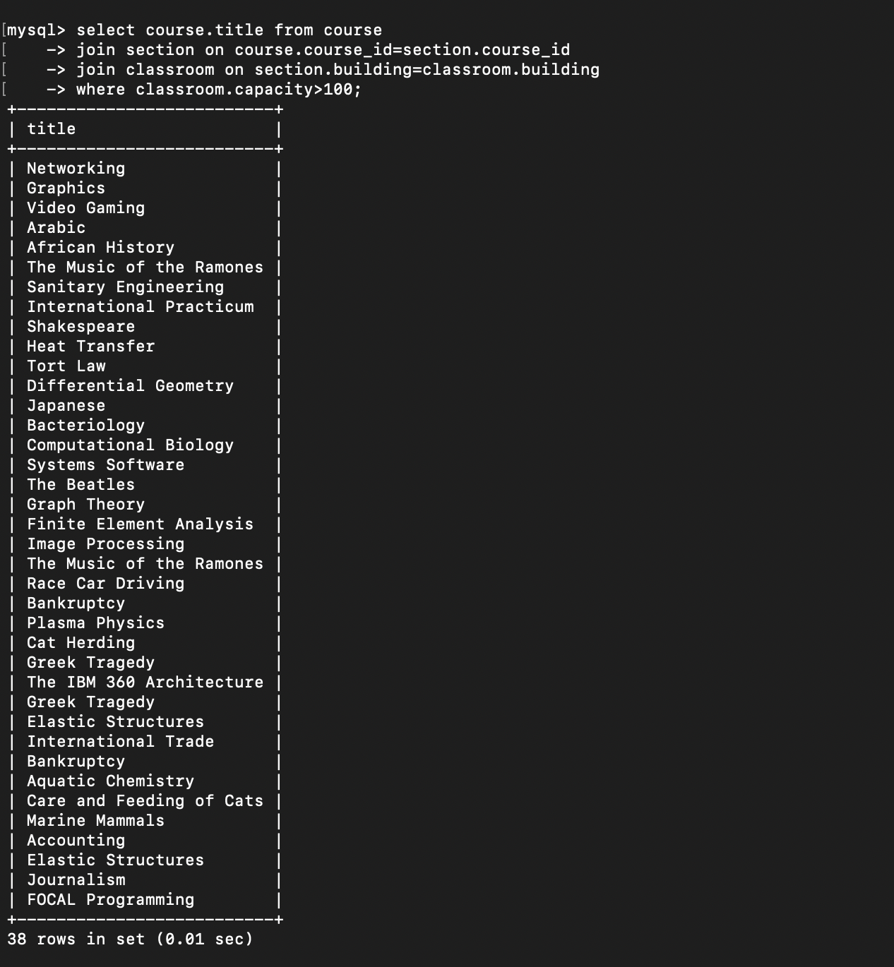

5. Find the total number of courses offered in the ‘Fall" semester.

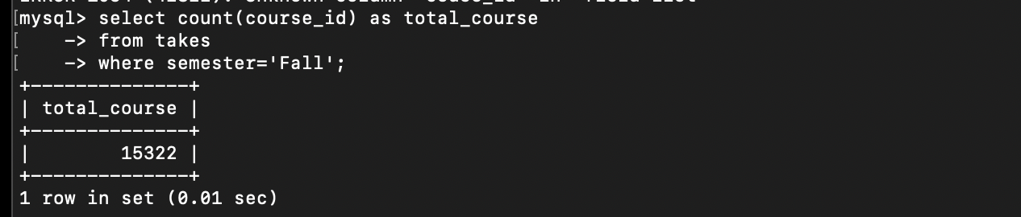

6. List all students who have taken exactly 30 total credits.

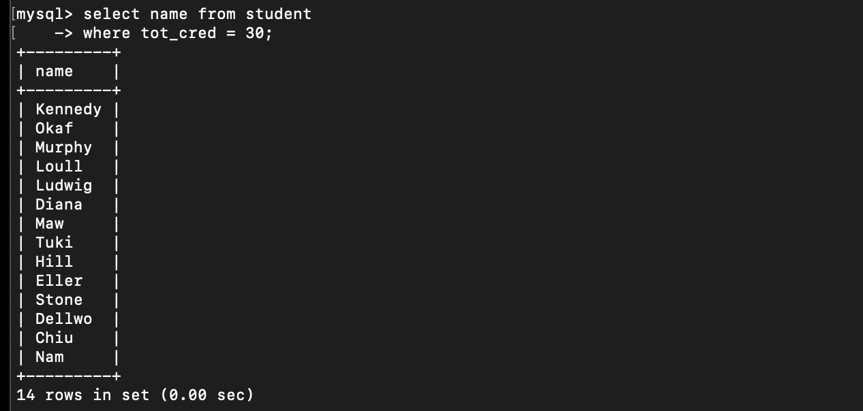

7. Find the names of all courses offered by the "Computer Science" department

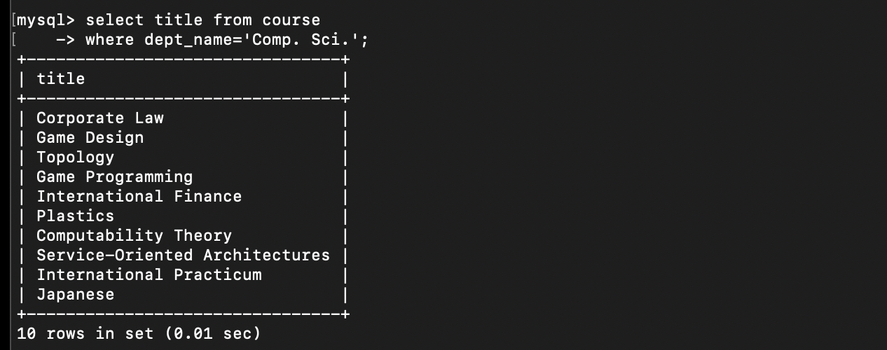

8. Retrieve the names of all instructors who earn more than ₹100,000.

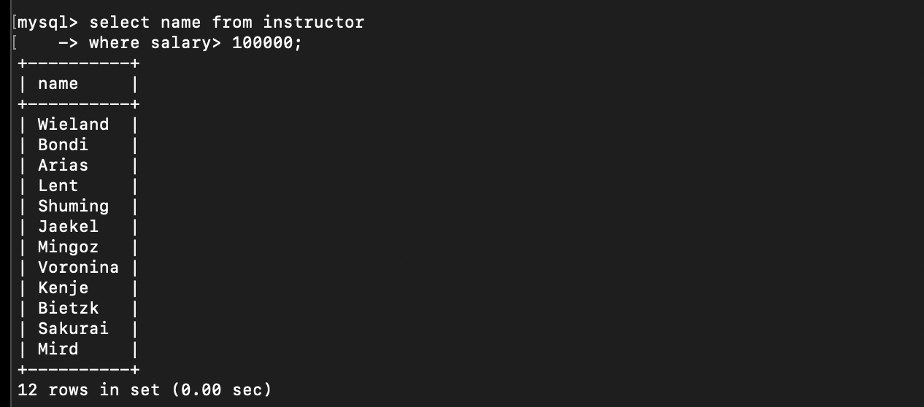

9. List all classrooms located in the "Taylor" building.

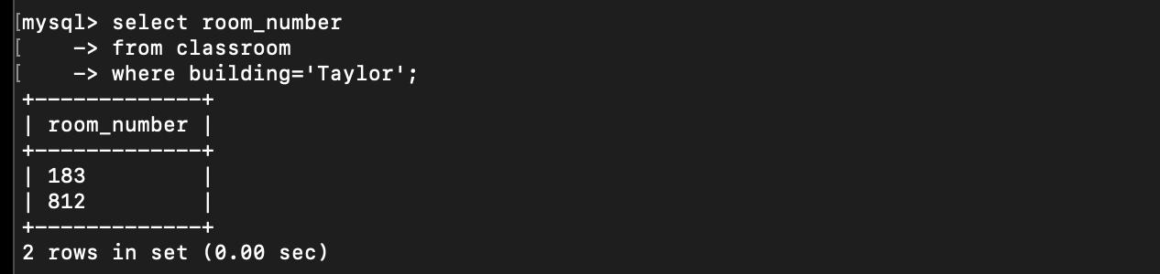

10. Find the total number of courses offered in the "Spring" semester

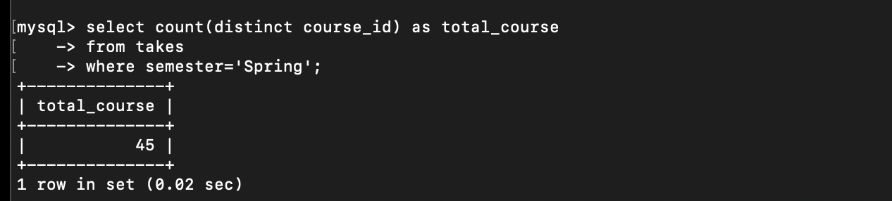

11. List total students who have taken courses with a grade of "C+" or lower.

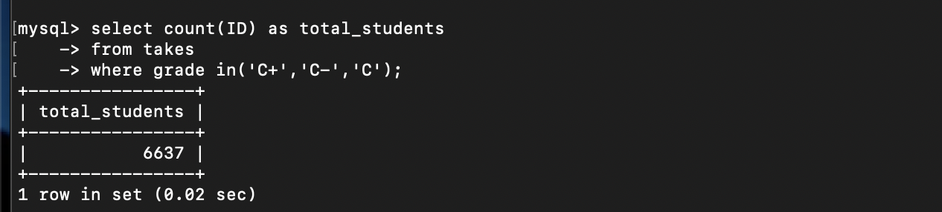

12. count number of instructors who have taught in the "Fall" semester of 2022.

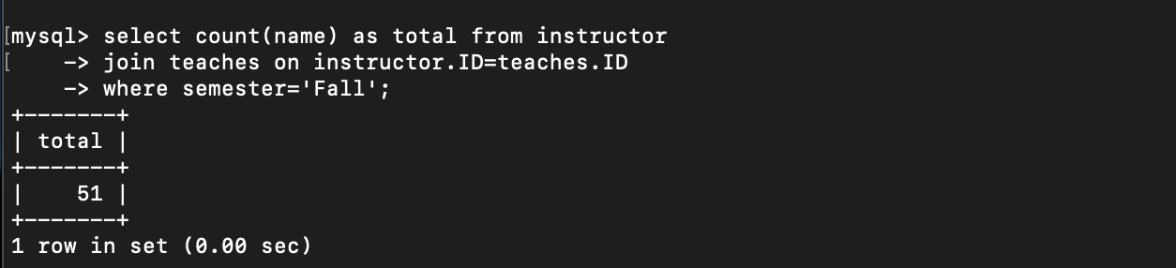

13. Find the average capacity of classrooms in each building.

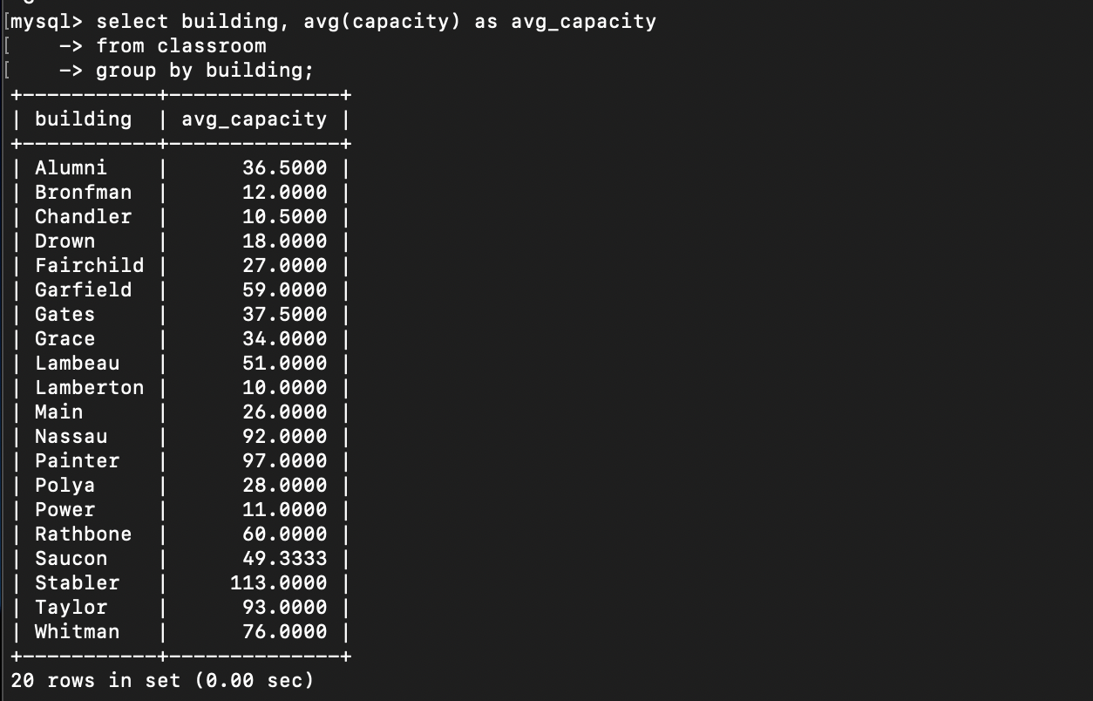

14. Total courses that have more than 3 credits.

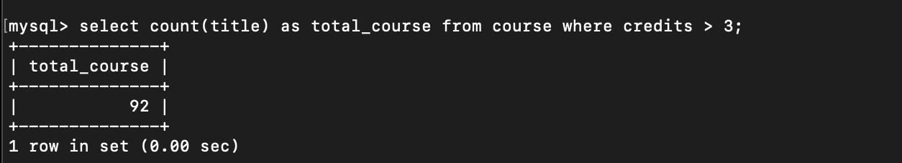

15. Retrieve the names of students who have taken courses in the "Whitman" building.

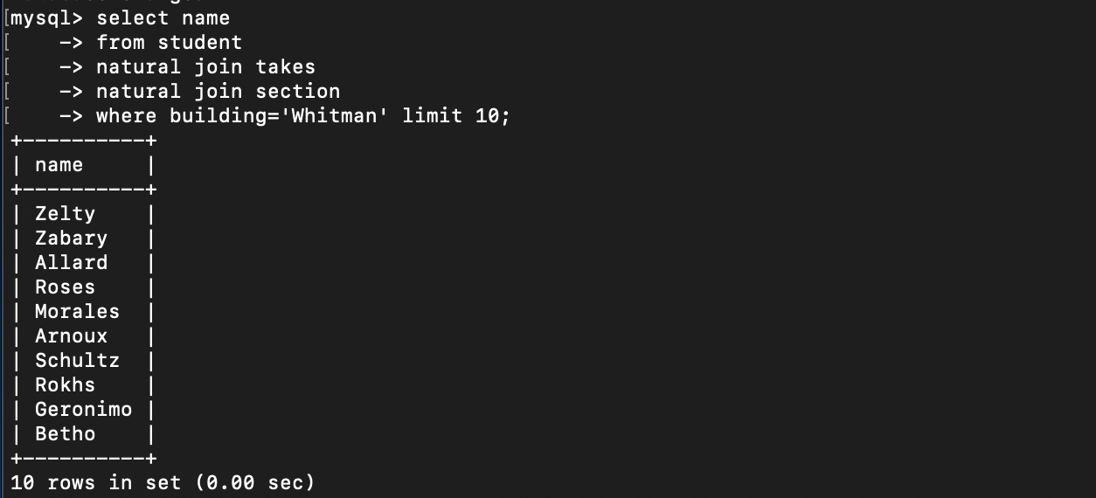

16. Find the total number of students advised by each instructor.

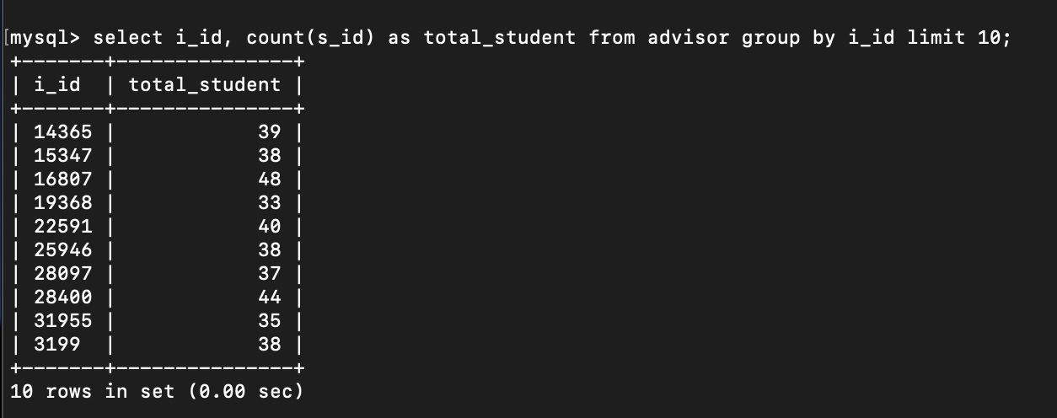

17. List all sections that do not have a classroom assigned.

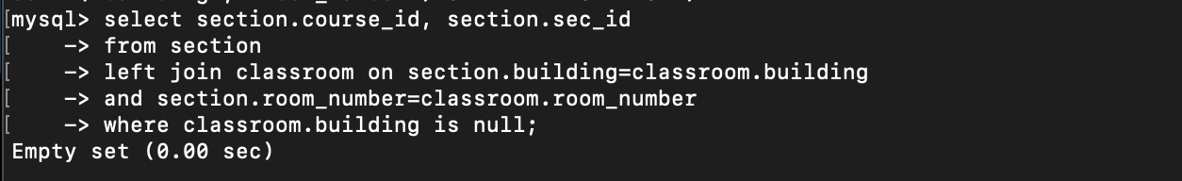

18. Retrieve the names of students who have taken courses with the highest number of

credits.

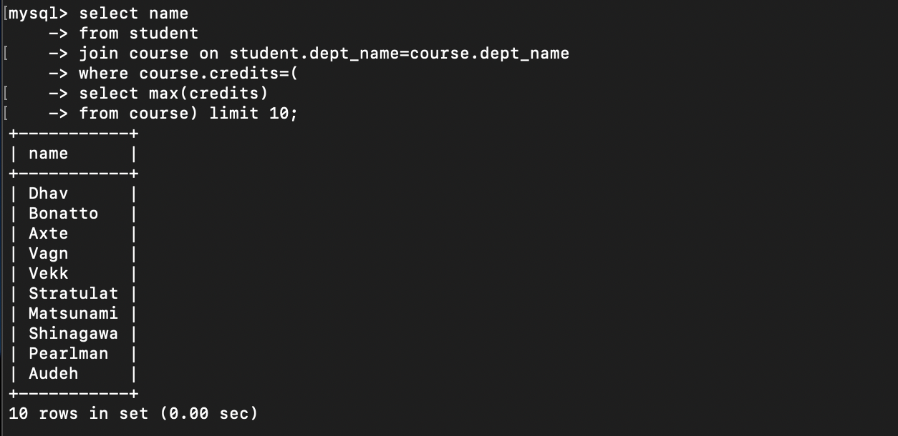

19. Find the departments with the highest average instructor salary.

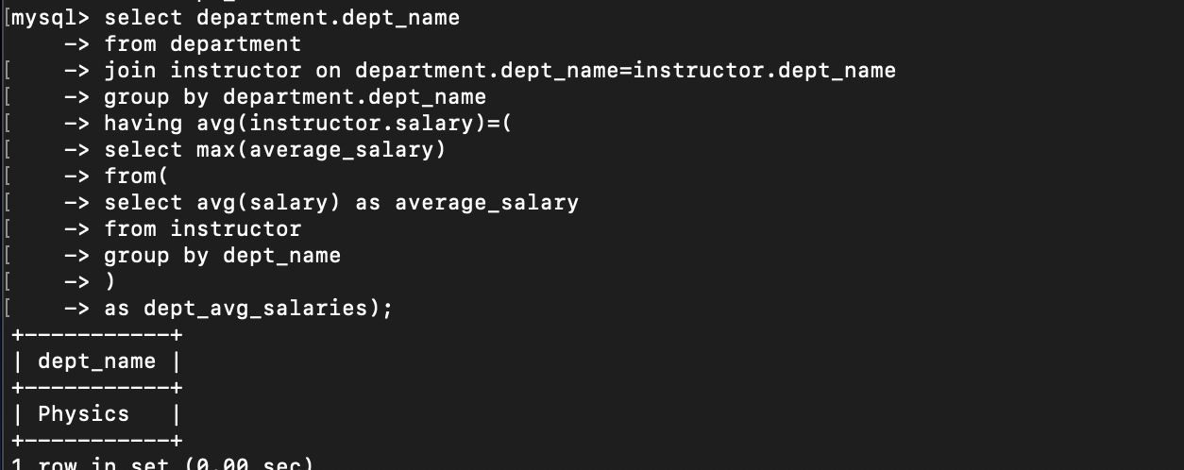

20. List all courses that have been taught by more than one instructor.

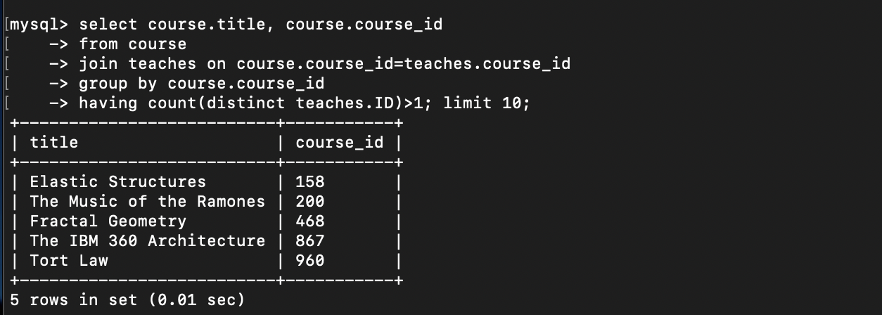

21. List all students who have taken courses with a grade of "A" in the "Fall" semester of

2022.

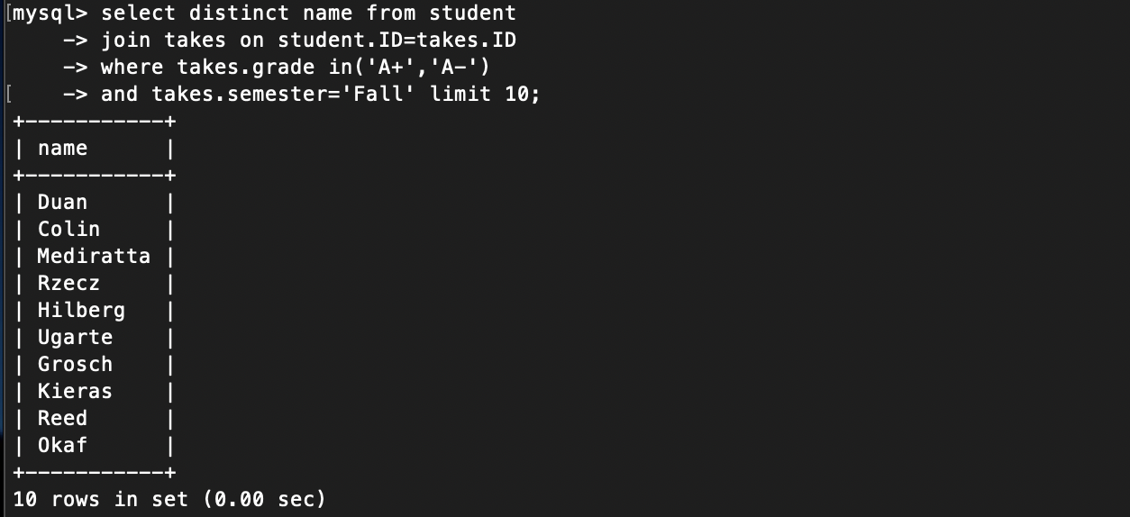

22. Retrieve the names of instructors who have taught in the "Spring" semester of 2023.

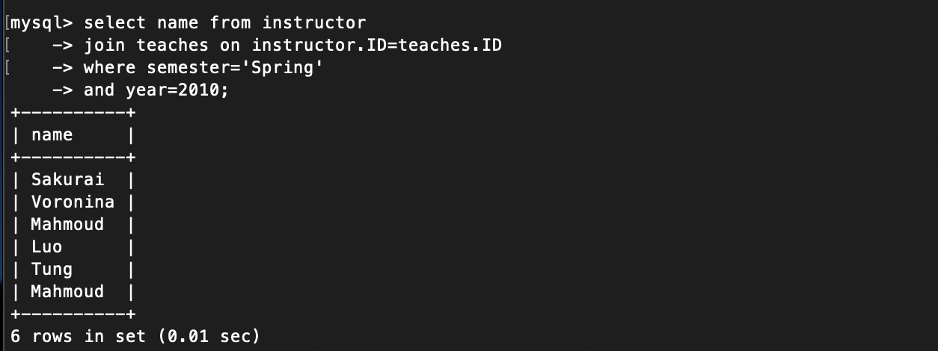

23. Find the average number of students enrolled in each course.

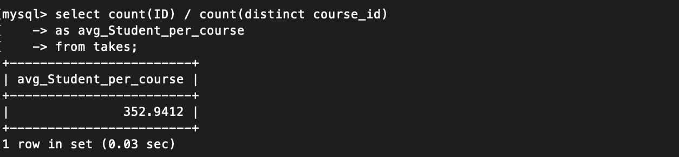

24. List all courses that have exactly 4 credits.

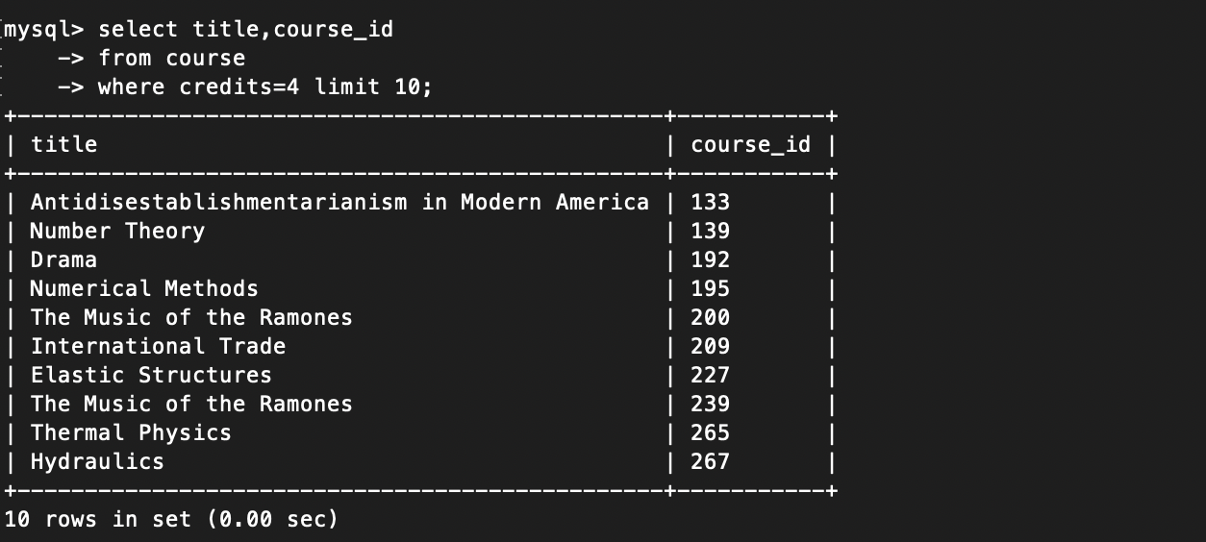

25. Retrieve the names of students who have taken courses in the "Packard" building.